A)

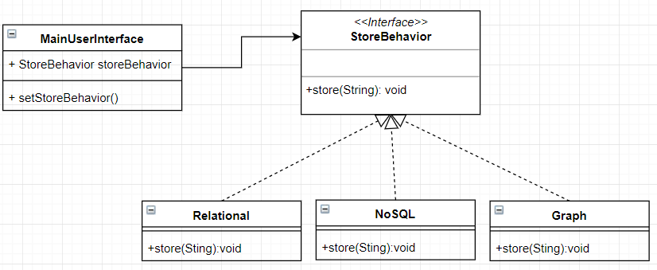

package ESOF_HW2;

import java.io.FileNotFoundException;P

import java.io.UnsupportedEncodingException;

import java.util.Scanner;

public class MainUserInterFace {

StoreBehavior storeBehavior;

public void setStoreStrategy(StoreBehavior sb){

storeBehavior = sb;

}

public static void main(String[] args) throws FileNotFoundException, UnsupportedEncodingException {

MainUserInterFace instanceData = new MainUserInterFace();

String data = "Here we stored the data using ";

Scanner scan = new Scanner(System.in); // Create a Scanner object

System.out.println("1 : Relational (table store) - default");

System.out.println("2 : NoSQL (document store)");

System.out.println("3 : Graph (node store)");

System.out.println("Which data storage would you like to use:");

while(!scan.hasNextInt()) {

System.out.println("Please enter an INT");

scan.next();

}

int dataTypeIn = scan.nextInt();

instanceData.setStoreStrategy(new Relational());

Relational defaultR = new Relational();

defaultR.store(data);

switch(dataTypeIn){

case 1:

instanceData.setStoreStrategy(new Relational());

break;

case 2:

instanceData.setStoreStrategy(new NoSQL());

break;

case 3:

instanceData.setStoreStrategy(new Graph());

break;

default:

instanceData.setStoreStrategy(new Relational());

}

instanceData.storeBehavior.store(data);

}

}

package ESOF_HW2;

import java.io.FileNotFoundException;

import java.io.UnsupportedEncodingException;

public interface StoreBehavior {

void store(String data) throws FileNotFoundException, UnsupportedEncodingException;

}

package ESOF_HW2;

import java.io.FileNotFoundException;

import java.io.PrintWriter;

import java.io.UnsupportedEncodingException;

public class Graph implements StoreBehavior {

public void store(String data) throws FileNotFoundException, UnsupportedEncodingException {

PrintWriter writer = new PrintWriter("output.txt");

writer.println(data + "node store in the Graph class.");

writer.close();

System.out.println(data+"node store in the Graph class.");

}

}

package ESOF_HW2;

import java.io.FileNotFoundException;

import java.io.PrintWriter;

import java.io.UnsupportedEncodingException;

public class Relational implements StoreBehavior{

public void store(String data) throws FileNotFoundException, UnsupportedEncodingException {

PrintWriter writer = new PrintWriter("output.txt");

writer.println(data + "table store in the class Relational.");

writer.close();

System.out.println(data+"table store in the class Relational.");

}

}

package ESOF_HW2;

import java.io.FileNotFoundException;

import java.io.PrintWriter;

import java.io.UnsupportedEncodingException;

public class NoSQL implements StoreBehavior{

public void store(String data) throws FileNotFoundException, UnsupportedEncodingException {

PrintWriter writer = new PrintWriter("output.txt");

writer.println(data + "document store in the class NoSQL.");

writer.close();

System.out.println(data + "document store in the class NoSQL.");

}

}

Terminal Output:

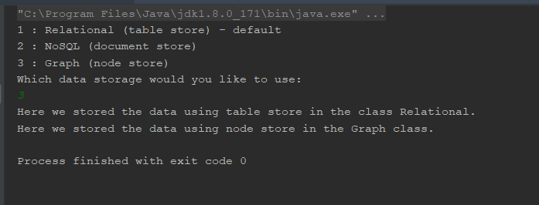

File Output

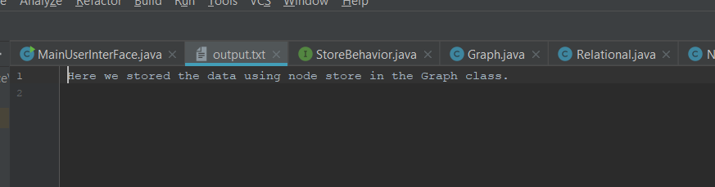

UML Sequence:

